|  |  |
| --- | --- |
| DATE | 7-11-2022 |
| TEAM ID | PNT2020TMID29237 |
| PROJECT NAME | Safety Gadget For Child Safety Monitoring & Notification |

# Project development delivery of sprint 3

* The Smart Mom architecture thus eases their work and helps them in taking care of the child It is also assumed that this systemis useful for children between ages five to fifteen years.
* Since, children below five years are years delicate to be taken care of by an autonomous system and children above fifteen years are grown up enough to be taken care of by their mothers pervasively.
* Smart Mom architecture is divided into two domains namely−the cloud environment and the home environment. Each domain is subdivided into a number of modules depending upon the application system.

# Notification module

The notification is responsible for sending notifications to the computing devices either at home or outside. The computing devicecan be wired or wireless and may belong to either the child, the governess, doctor or the mother of the child depending upon the needed application.

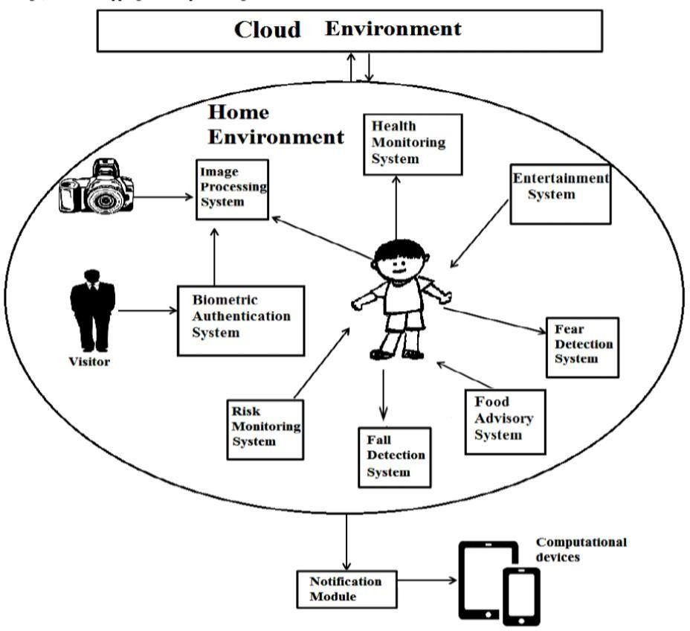

**Python Serial Loopback Test**

import serial

#####Global Variables######################################

#be sure to declare the variable as 'global var' in the fxnser = 0

#####FUNCTIONS#############################################

#initialize serial connectiondef init_serial():

COMNUM = 9 #set you COM port # here

global ser #must be declared in each fxn usedser = serial.Serial()

ser.baudrate = 9600

ser.port = COMNUM - 1 #starts at 0, so subtract 1#ser.port = '/dev/ttyUSB0' #uncomment for linux

#you must specify a timeout (in seconds) so that the# serial port doesn't hang

ser.timeout = 1

ser.open() #open the serial port

# print port open or closedif ser.isOpen():

print 'Open: ' + ser.portstr #####SETUP################################################

#this is a good spot to run your initializationsinit_serial()

#####MAIN LOOP############################################

while 1:

#prints what is sent in on the serial port

temp = raw_input('Type what you want to send, hit enter:\n\r')

ser.write(temp) #write to the serial port

bytes = ser.readline() #reads in bytes followed by a newline print 'You sent: ' + bytes #print to the console

break #jump out of loop

#hit ctr-c to close python window

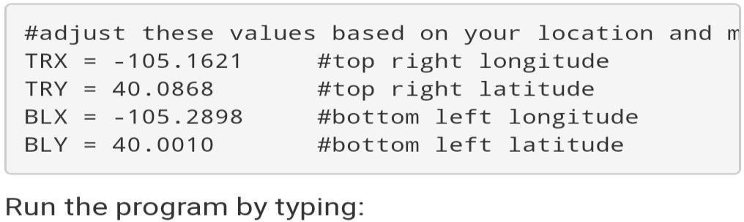

1. High-level language software design has long stayed in use for surrounded-systems growth.
2. Though, assemblage programming still overwhelms, mostly for digital-signal processor (DSP) based systems.
3. DSPs are frequency systems automatic in assembly language by computer operator who know the processor building inside out. The key incentive for this practice is performance, even with the disadvantages of assembly software design when linked to high- level programming.